Chapter 1
The Nature of Economics

Overview
This chapter introduces economics as a science. Economics is defined, and its subareas, macroeconomics and microeconomics, are introduced. The chapter also discusses the three fundamental questions faced by every nation of what to produce, how to produce, and for whom to produce. The chapter then presents the two types of economic systems, command and control or the price system, used to answer the three fundamental questions. Economic rationality and self-interest are discussed along with their implications for decision making and economic model building. The concept of behavioral economics is introduced. Economics as a science is closely associated with the development of models. To aid understanding, a significant section on the methodology of economics discusses model construction, the role of assumptions, and determining the usefulness of a model. Finally, the difference between positive and normative economics is presented. There is a discussion of why it is important to separate these two areas of analysis clearly.

Learning Objectives
After studying this chapter, students should be able to:
• 1.1 Define economics and discuss the difference between microeconomics and macroeconomics
• 1.2 Identify the three basic economic questions and the two opposing sets of answers
• 1.3 Evaluate the role that rational self-interest plays in economic analysis
• 1.4 Explain why economics is a science
• 1.5 Distinguish between positive and normative economics

Outline
I. The Power of Economic Analysis: The analytical framework of the course is the economic way of thinking. The economic way of thinking permits the student to reach informed conclusions about what is happening in the world.
A. Defining Economics: The study of how people allocate their limited resources to satisfy their unlimited wants. The ultimate purpose of economics is to explain how people make choices.
B. Microeconomics versus Macroeconomics: Economics is divided into two types of analysis: macroeconomics and microeconomics.
1. Microeconomics: The part of economic analysis that studies individual decision making undertaken by individuals (or households) and by firms.
2. Macroeconomics: The part of economic analysis that studies the behavior of the economy as a whole. It deals with economywide phenomena such as changes in unemployment, the general price level, and national income.
II. The Three Basic Economic Questions and Two Opposing Sets of Answers: Every nation must address three fundamental questions that concern the problem of how an economic system allocates a society’s scarce resources.
A. The Three Basic Questions: (1) What will be produced? (2) How will items be produced? (3) For whom will it be produced?
B. Two Opposing Sets of Answers
1. Centralized Command and Control: Also called a command and control system, this system has a centralized authority that decides what items to produce and how many of each, determines how the scarce resources will be organized in the items’ production, and identifies who will be able to obtain the items.
2. The Price System: Also called a market system, a price system is an economic system that answers the three basic questions using decentralized decision making. In a pure price system, individuals own all of the scarce resources used in production. This means those choices about what and how many of each item to produce are made by private parties on their own initiative, as are the decisions about how to produce those items. Finally, individuals and families choose how to allocate their incomes to obtain those items at prices established by privately organized mechanisms. Those prices in turn signal everyone in a price system relative scarcity of different resources, which in turn provides information about what and how many items to produce, how to produce each, and who will choose to buy the items.
3. Mixed Economic Systems: The economic systems of the world incorporate aspects of both centralized command and control and the decentralized price systems.
III. The Economic Approach: Systematic Decisions: Economists assume that individuals act as if they pursue self-motivated interests and respond predictably to perceived opportunities to obtain those interests.
A. The Rationality Assumption: The assumption that individuals will not intentionally make decisions that would leave them worse off.
B. Responding to Incentives: An incentive is the reward for engaging in a given activity. People react to an incentive by making a rough comparison of costs and benefits. A negative incentive raises the cost of doing something. If benefits of a given choice do not change, then a higher cost (negative incentive) will decrease or perhaps eliminate a particular choice.
C. Defining Self-Interest: The pursuit of goals that make the individual feel better off. In economic analysis, these goals are often those which can be measured in monetary terms, although the pursuit of other goals such as prestige, love, or power can be analyzed using this concept.
IV. Economics as a Science: Economics is a social science that utilizes the same types of methods
used in biology, chemistry, and physics. Economic models or theories, which are simplified representations of the real world, are developed and used as aids in understanding, explaining, and predicting economic phenomena in the real world.
A. Models and Realism: A model should capture the essential relationships that are sufficient to analyze the specific problem or answer the specific question being asked. No economic model
is complete in the sense of capturing every detail and relationship that exists in the real world.
A model is by definition an abstraction from reality. This does not mean that models are deficient simply because they are unrealistic and use simplified assumptions. Every model in every science requires simplification compared to the real world.
B. Assumptions: Assumptions define the set of circumstances in which a model is most likely to be applicable. Every model, therefore, must be based on a set of assumptions.
1. The Ceteris Paribus Assumption: All Other Things Being Equal: The assumption that nothing changes except the factors being studied. It is used to isolate the effect of a change in one variable on another one by assuming that all other variables do not change.
C. Deciding on the Usefulness of a Model: A model is useful if it yields usable predictions supported by real-world observations. If a model makes a prediction and factual evidence supports the prediction, then the model is useful. Thus economics is an empirical science; that is, it relies on real-world data in evaluating the usefulness of a model.
D. Models of Behavior, Not Thought Processes: Models relate to the way people act in using limited resources and not to the way they think. Models normally generalize people’s behavior. Economists are interested in what people actually do, i.e., revealed preferences, rather than what they think they will do, ( declared preferences).
E. Behavioral Economics and Bounded Rationality: An approach to consumer behavior that emphasizes psychological limitations and complications that potentially interfere with rational decision making.
1. Bounded Rationality: The idea that people are nearly, but not fully, rational so that they cannot examine every choice available to them but instead use simple rules of thumb to sort among the alternative available to them.
2. Rules of Thumb: A behavioral implication of bounded rationality is that people will use rules of thumb; that is, a simplified method of decision making. An important issue is that persons who appear to use rules of thumb may behave as if they are fully rational.
3. Behavioral Economics: A Work in Progress: So far, proponents of behavioral economics have not conclusively demonstrated that paying closer attention to psychological thought processes can improve economic predictions.
V. Positive versus Normative Economics: Positive economics deals with what is. Positive economic statements are “if-then” statements. Normative economics deals with what some person thinks ought to be. Normative economic statements involve value judgments and normally have the words “ought” or “should” in them. Because positive economics predicts consequences of actions, it can be used to predict the effects of various policies to see if the policies aid in achieving desired goals. Positive economics cannot provide criteria for choosing which outcomes or goals are preferable.
A. Distinguishing between Positive and Normative Economics: Positive economics is analysis that is strictly limited to making either purely descriptive statements or scientific predictions. Normative economics is analysis involving value judgments about economic policies,
a statement about what ought to be.
B. A Warning: Recognize Normative Analysis: Although it is easy to define positive economics, it is often difficult to identify unlabeled normative statements, even in a textbook.

Points to Emphasize

The Discipline of Economics
Economics is the study of how people make choices to satisfy their wants. Wants have a special meaning in economics. Wants represent those things that people would buy if they had unlimited income. In economics, we note that income is in fact limited, and thus, people must make choices. These choices are made on the basis of rational self-interest. This means that people make choices that, in their view, make them better off. People do not voluntarily make choices that they believe will make them worse off. This assumption of rational behavior underlies all economic decision making.

Economic Systems and the Allocation of Scarce Resources
Because resources are scarce, every nation must answer the three fundamental questions of what and how much of each item to produce, how each item will be produced, and for whom items will be produced. Emphasize that there are not enough resources to produce as much of everything that the citizens of any nation would want. Thus scarcity requires that choices be made as to which items and how many of each will be produced. Because resources are scarce, decisions about which and how many of each type of resource will be employed to produce those items are to be made. Again, compared to wants, resources are limited. Scarcity also means in practice that everyone cannot have as much of everything that they would like to have. Thus some mechanism must exist to allocate what finally gets produced to the members of each nation.

Economic Models
Economic models are simplified representations of the real world. Economic models frequently present problems for students because they are so abstract. The goal is for students to realize that only essential relationships are needed to deal with the problem at hand. A classic example of using an abstract theory is the decision of whether or not to take an umbrella when going outside. If a person misses the weather report, the person can look outside at the sky. If the sky is overcast or if dark clouds can be seen in the distance, then a prudent person will carry an umbrella. A person reasons that clouds are often associated with rain. If there are clouds of a certain type, then rain is likely but not certain. To actually know if rain will fall in a given place requires a complete knowledge of atmospheric conditions in a rather large area. Even the weather service does not have this kind of information. The simplest theory that can predict is the one that should be used.

Prediction—The Test of a Theory
A model is useful only if it predicts, i.e., if it yields useful implications of how things happen in the real world. It is not correct to fault a model because its assumptions are not realistic or because it is too abstract. The test of a theory is its ability to predict. Economists cannot do controlled experiments the way chemists can. What is done instead is to look at evidence to see if the model can predict. Normally tests uses statistical evidence and techniques. A great deal of economic research consists of empirical testing of theories.

The Individual in Economic Analysis
The unit of analysis is the individual. It is often difficult for students to distinguish between the individual as an abstraction and a given individual in the real world. The difference between the two can be explained in the following way. The individual as an abstraction is a hypothetical typical individual or as psychologists would say a normal individual. This is a “person” whose behavior is that which is expected most of the time from most persons. Obviously, it is possible to find actual persons who are “abnormal” or who do not behave in the typical way. When we say that the individual is motivated by rational self-interest, this does not exclude the possibility that some persons may choose to not act in their own self-interest (e.g., someone sacrificing his or her life to save a child). It only says that in most of our affairs, we choose to do those things that we believe will benefit us in some way and we choose not to do those things that we believe will make us worse off. Economists have found that economic models work best when the individual is the unit of analysis because individuals making choices are at the basis of every decision.

Positive versus Normative Economics
The text points out that normative economics can be identified by the use of the word “should.” Other words that provide a flag that a normative statement instead of a positive statement is being made are good, bad, best, desirable, undesirable, better, and worse. Examples of these are as follows:

1. An increase in extended unemployment benefits is good because the benefits reduce the hardship faced by the unemployed.

2. Increases in interest rates by the Federal Reserve are bad because higher interest rates hurt low-income borrowers.

3. The best policy to get the economy out of a recession is to cut taxes.

4. High gasoline prices are undesirable.

5. It would be desirable to lower the prices of drugs to combat AIDS in poor countries.

6. The increase in prescription drug prices is undesirable because many senior citizens must choose between their drugs and food.

7. It is better to increase the progressive income tax than to increase a regressive sales tax.

8. Of the two methods of financing the war in Afghanistan, it is better to raise taxes on the American people rather than to borrow the money.

For Those Who Wish to Stress Theory

Unrealistic Assumptions of Economic Models?
One of the more frustrating aspects of economic analysis is what appears to be the unrealistic assumptions of many economic models. For example, in the realm of macroeconomics, the rational expectations hypothesis in its pure form talks about workers not being fooled by expected changes in the money supply by the Federal Reserve. It is true that most workers cannot tell you what the latest money supply growth rate figures are. They do not subscribe to the Federal Reserve Bulletin or read the Federal Open Market Committee report. However, workers do respond to what they perceive to be the expected state of the economy as it affects them. If the Fed is increasing the money supply at a faster rate and the inflation rate rises, workers will react as if they had a model of expected inflation. It is their behavior that we measure and predict, not what they are thinking. If the assumption of economic rationality is correct, then they will not be systematically fooled. One approach to explaining the same approach outside economics is to point out that it is highly unlikely that a champion pool player knows the laws of physics with regard to the exact force needed to hit the cue ball and the mathematical formulas needed to compute the exact angle to hit the pool table bank, but his behavior is the same as if he did.

Further Questions for Class Discussion

1. Political disturbances such as wars and threats of wars in the Middle East often lead to increases in the price of oil. You will often hear people say that the U.S. government should not let the price rise. Ask your students the difference between these statements. Obviously, the first is a positive statement. Generally, a political disturbance actually leads to reduced supplies or to fears of reduced supplies, or both. Price then rises. Whether or not oil prices should rise is a normative statement. Nothing scientific can be said about it because it is based on a value judgment.

2. It is worth examining the idea that changes in incentives cause people to change their behavior. For example, any decrease in costs tends to encourage an activity, ceteris paribus. In recent years, cell phone texting as a part of many plan service contracts has become unlimited at the fixed monthly service contract price, while the number of “free” minutes spent talking on the phone is limited under most plans. What has happened to the use of texting versus calling as a method of communicating? Students report that texting has become the primary means of communication using cell phones with the number of text messages sent per month reaching into the thousands. In one university, a coed reported that the largest number of text messages that she sent in one month was more than 13,000.

3. An important issue raised after the financial meltdown in 2008 and the resulting recession has been how to deal with the recession. The economic stimulus policies of cutting taxes and increasing government spending contributed to a very large increase in the federal government’s deficit. As a result, the recession moderated, and economic growth replaced the falling gross domestic product (GDP). During this period, a debate began in the United States that the size of government had gotten too large and therefore that spending should be cut. Discuss the positive and normative economic issues presented. Positive: These are that the increases in government spending that have contributed to a large increase in the federal deficit and that the result was also that economic growth resumed. These are positive issues because they are testable statements about the economic effect of increases in federal spending and reduced taxes on the size of the federal deficit as well as the effect of increased spending and tax cuts on the level of economic activity. Normative: The statements that “the size of government had gotten too large and that spending should be cut” are not testable—they are based on value judgments about what “ought to be.”

4. Some widely reported and watched polls are viewed as economic indicators of future levels of economic activity and as various measures of “consumer confidence.” The Conference Board, the University of Michigan, and ABC News/Money Magazine all use polls of consumers to measure their confidence in the economy. Polls ask people what they think about the economy and what their spending plans are but do not actually measure what people do. Why are polls such as these not likely to provide a reliable model for predictions? The answer is that polls look at what people believe that they are planning to do rather than what they actually do.

5. Scarcity forces society to come up with a mechanism to determine how output is to be distributed. Students can be asked if price is not to be used as an allocative mechanism, then what do they suggest? Suggest that the university allocate seats in courses on the basis of price. Let students bid for available seats in classes, rather than using a first-come, first-served system based on some sort of administrative procedure. An objection to this allocation method is almost certainly that the wealthier students would get the most desirable courses with the best professors, and poorer students would get the less desirable ones with less talented professors. Suppose that the university responds by providing more sections of the high-demand courses by paying the best professors more to teach an overload? The availability of seats will thus increase, and more students can take the course. Under administrative methods, there is little or no incentive to make more sections available (e.g., by paying qualified professors more to teach an overload in the short run and in the long run by hiring more faculty in those areas).

Answers to Questions for Critical Analysis

Government Green Energy Financing Flops (p. 4)
Ultimately, who pays for such green energy projects that fail?
Ultimately, taxpayers are the ones who will pay for green energy projects that fail.

In China, Chonqing Plus Guangdon Equals a Mixed Economy (p. 6)
Why might government-owned companies and private firms that produce steel respond differently if steel buyers purchase less?
Private firms are owned by individuals who have more incentive to respond to consumer demand than government-owned companies, which are not owned by individuals.

Why Did Costco Borrow $3.5 Billion to Distribute to Its Shareholders (p. 7)
How do you think that individual taxpayers responded to the increase in dividend tax rates?
Taxpayers would respond to the increase in the dividend tax rates by reducing their holding of stocks that pay dividends and increase their holding of other investment instruments.

Taking Care of Others—and Self (p. 8)
Why do you suppose economists have found evidence that people tend to give more to charities when they are currently in good health but reduce their giving when they anticipate they will shortly die?
People tend to give more to charities when they are in good health because charitable donations are tax deductible, so that they can take advantage of the donations to reduce their own federal tax bills.

Getting Directions (p. 9)
In what way do small talk and gossip represent the use of simplifying assumptions?
Gossip and small talk usually deal with other persons or situations of interest to the persons engaged in the conversation. Often the people who are talking choose to leave out details which they consider unimportant or that do not support their position. The interpretation of the situation or the behavior of the person being talked about will be affected by which details are omitted.

You Are There

How a Tax Differential Aided a Texas Pro Basketball Team (p. 12)

1. What is the nature of the incentive that appears to have predominated in influencing Howard’s choice about where to play basketball?

The after-tax income for Dwight Howard is the incentive that influences his choice to play basketball in Houston. Because Texas has no state income tax but California does, Howard’s income after tax will be more than $500,000 per year higher if he plays in Texas.

Does Howard appear to have engaged in behavior consistent with the rationality assumption?

2. Dwight Howard appears to have responded to an economic incentive, and so his behavior is consistent with the rationality assumption.

Issues & Applications

Incentive Effects of Student Loans for College Graduates (p. 13)

1. Why do you suppose that people with student loan debts wait longer to get married and to have children than people without debts?

Student loan debts are disincentives for people to incur large expenses. Because being married and having children involve more expenses than being single without children, people with more debts tend to wait longer to get married and have children than people without debts.

2. Is regretting a previous decision inconsistent with the individual’s self-interest at the time the decision was made?

When a person making a decision and does not intend to make herself worse off at that time, the decision is consistent with her self-interest. The outcome, however, may be different from what she expected.

Answers to Problems

1-1. Define economics. Explain briefly how the economic way of thinking—in terms of rational, self-interested people responding to incentives—relates to each of the following situations. (See pages 2, 6–7.)

a. A student deciding whether to purchase a text- book for a particular class

b. Government officials seeking more funding for mass transit through higher taxes

c. A municipality taxing hotel guests to obtain funding for a new sports stadium

Economics is the study of how individuals allocate limited resources to satisfy unlimited wants.
a. Among the factors that a rational, self-interested student will take into account are her income, the price of the textbook, her anticipation of how much she is likely to study the textbook, and how much studying the book is likely to affect her grade.
b. A rational, self-interested government official will, for example, recognize that higher taxes will raise more funds for mass transit while making more voters, who have limited resources, willing to elect other officials.
c. A municipality’s rational, self-interested government will, for instance, take into account that higher hotel taxes will produce more funds if as many visitors continue staying at hotels, but that the higher taxes will also discourage some visitors from spending nights at hotels.

1-2. Some people claim that the “economic way of thinking” does not apply to issues such as health care. Explain how economics does apply to this issue by developing a “model” of an individual’s choices. (See pages 8–9.)

This issue involves choice and, therefore, can be approached using the economic way of thinking. In the case of health care, an individual typically has an unlimited desire for good health. The individual has a limited budget and limited time, however. She must allocate her budget across other desirable goods, such as housing and food, and must allocate her time across waiting in a physician’s office, work, leisure, and sleep. Hence, choices must be made in light of limited resources.

1-3. Does the phrase “unlimited wants and limited resources” apply to both a low-income household and a middle-income household? Can the same phrase be applied to a very high-income household? (See page 2.)

Because wants are unlimited, the phrase applies to very high-income households as well as low- and middle-income households. Consider, for instance, a household with a low income and unlimited wants at the beginning of the year. The household’s wants will still remain unlimited if it becomes a high-income household later in the year.

1-4. In a single sentence, contrast microeconomics and macroeconomics. Next, categorize each of the following issues as a microeconomic issue, a macroeconomic issue, or not an economic issue. (See page 3.)

a. The national unemployment rate

b. The decision of a worker to work overtime or not

c. A family’s choice to have a baby

d. The rate of growth of the money supply

e. The national government’s budget deficit

f. A student’s allocation of study time across two subjects

Microeconomics is the study of individual decision making, whereas macroeconomics examines the aggregate behavior of the entire economy.

a. macroeconomics

b. microeconomics

c. microeconomics

d. macroeconomics

e. macroeconomics

f. microeconomics

1-5. One of your classmates, Sally, is a hardworking student, serious about her classes, and conscientious about her grades. Sally is also involved, however, in volunteer activities and an extracurricular sport. Is Sally displaying rational behavior? Based on what you read in this chapter, construct an argument supporting the conclusion that she is. (See pages 6–8.)

Sally is displaying rational behavior if all of these activities are in her self-interest. For example, Sally likely derives intrinsic benefit from volunteer and extracurricular activities and may believe that these activities, along with good grades, improve her prospects of finding a job after she completes her studies. Hence, these activities are in her self-interest even though they reduce some available study time.

1-6. Recently, a bank was trying to decide what fee to charge for “expedited payments”—payments the bank would transmit with extra speed so that customers could avoid late fees on cable TV bills, electric bills, and the like. To try to determine what fee customers were willing to pay for expedited payments, the bank conducted a survey. It was able to determine that many of the people surveyed already paid fees for expedited payment services that exceeded the maximum fees they said they were willing to pay. How does the bank’s finding relate to economists’ traditional focus on what people do, rather than what they say they will do? (See page 10.)

This example illustrates that what people say they will do does not actually correspond to what matters in the economy, which is what they actually do.

1-7. Explain, in your own words, the rationality assumption, and contrast it with the assumption of bounded rationality proposed by adherents of behavioral economics. (See pages 6–7, 10–11.)

The rationality assumption states that people do not intentionally make choices that leave them worse off. The bounded rationality hypothesis suggests that people are almost, but not completely, rational.

1-8. Why does the assumption of bounded rationality suggest that people might use rules of thumb to guide their decision making instead of considering every possible choice available to them? (See page 10.)

The bounded rationality hypothesis indicates that because people cannot study every possible alternative available to them, they consider only the most obvious apparent choices. They find easy ways of deciding which of these obvious choices to select, and according to the hypothesis, these methods are simple rules of thumb.

1-9. Why does the assumption of bounded rationality suggest that people might use rules of thumb to guide their decision making instead of considering every possible choice available to them? (See page 10.)

Suppose that there is a change in the environment that a person faces, and the person adjusts to this change as predicted by the rationality assumption. If the new environment becomes predictable, then the individual who actually behaves as predicted by the traditional rationality assumption may settle into behavior that appears to involve repetitive applications of a rule of thumb.

1-10. For each of the following approaches that an economist might follow in examining a decision- making process, identify whether the approach relies on the rationality assumption or on the assumption of bounded rationality. (See page 10.)

a. To make predictions about how many apps a person will download onto her tablet device, an economist presumes that the individual faces limitations that make it impossible for her to examine every possible choice among relevant apps.

b. In evaluating the price that an individual will be willing to pay for a given quantity of a particular type of health-care service, a researcher assumes that the person considers all relevant health-care options in pursuit of his own long-term satisfaction with resulting health outcomes.

c. To determine the amount of time that a person will decide to devote to watching online videos each week, an economist makes the assumption that the individual will feel overwhelmed by the sheer volume of videos available online and will respond by using a rule of thumb.

a. Bounded rationality

b. Rationality assumption

c. Bounded rationality

1-11. For each of the following approaches that an economist might follow in examining a decision- making process, identify whether the approach relies on the rationality assumption or on the assumption of bounded rationality. (See page 10.)

a. An economic study of the number of online searches that individuals conduct before selecting a particular item to purchase online presumes that people are interested only in their own satisfaction, pursue their ultimate objectives, and consider every relevant option.

b. An economist seeking to predict the effect that an increase in a state’s sales tax rate will have on consumers’ purchases of goods and services presumes that people are limited in their ability to process information about how the tax-rate increase will influence the after-tax prices those consumers will pay.

c. To evaluate the impact of an increase in the range of choices that an individual confronts when deciding among devices for accessing the Internet, an economic researcher makes the assumption that the individual is unable to take into account every new Internet-access option available to her.

a. Rationality assumption

b. Bounded rationality

c. Bounded rationality

1-12. Which of the following predictions appear(s) to follow from a model based on the assumption that rational, self-interested individuals respond to incentives? (See pages 6–8.)

a. For every ten exam points Myrna must earn in order to pass her economics course and meet her graduation requirements, she will study one additional hour for her economics test next week.

b. A coin toss will best predict Leonardo’s decision about whether to purchase an expensive business suit or an inexpensive casual outfit to wear next week when he interviews for a high-paying job he is seeking.

c. Celeste, who uses earnings from her regularly scheduled hours of part-time work to pay for her room and board at college, will decide to purchase and download a newly released video this week only if she is able to work two additional hours.

a. Yes, because Myrna is acting in her own self-interest by establishing this allocation of her time to studying economics.

b. No, because Leonardo is leaving an important decision affecting his self-interest to random chance, potentially leaving him worse off if he fails to obtain employment.

c. Yes, because Celeste is basing her choice on a self-interest assessment of expenditures in light of available resources.

1-13. Consider two models for estimating, in advance of an election, the shares of votes that will go to rival candidates. According to one model, pollsters’ surveys of a randomly chosen set of registered voters before an election can be used to forecast the percentage of votes that each candidate will receive. The above model relies on the assumption that unpaid survey respondents will give truthful responses about how they will vote and that they will actually cast a ballot in the election. The other model uses prices of financial assets (legally binding IOUs) issued by the Iowa Electronic Markets, operated by the University of Iowa, to predict electoral outcomes. The final payments received by owners of these assets, which can be bought or sold during the weeks and days preceding an election, depend on the shares of votes the candidates actually end up receiving. This second model assumes that owners of these assets wish to earn the highest possible returns, and it predicts that the market prices of these assets provide an indication of the percentage of votes that each candidate will actually receive on the day of the election. (See pages 8–9.)

a. Which of these two models for forecasting electoral results is more firmly based on the rationality assumption of economics?

b. How would an economist evaluate which is the better model for forecasting electoral out- comes?

a. The model using prices from the Iowa Electronic Market is based more firmly on the rationality assumption because people who trade assets on this exchange based on poor forecasts actually experience losses. This gives them a strong incentive to make the best possible forecasts. Unpaid respondents to opinion polls have less incentive to give truthful answers about whether and how they will vote.

b. An economist would develop a means of evaluating whether prices in the Iowa Electronic Market or results of opinion polls did a better job of matching actual electoral outcomes.

1-14. Write a sentence contrasting positive and normative economic analysis. (See pages 11–12.)

Positive economic analysis deals with economics models with predictions that are statements of fact, which can be objectively proved or disproved. Normative analysis takes into account subjective personal or social values concerning the way things ought to be.

1-15. Based on your answer to Problem 1–14, categorize each of the following conclusions as resulting from positive analysis or normative analysis. (See pages 11–12.)

a. A higher minimum wage will reduce employment opportunities for minimum wage workers.

b. Increasing the earnings of minimum wage employees is desirable, and raising the minimum wage is the best way to accomplish this.

c. Everyone should enjoy open access to health care at no explicit charge.

d. Heath-care subsidies will increase the consumption of health care.

a. Positive

b. Normative

c. Normative

d. Positive

1-16. Consider the following statements, based on a positive economic analysis that assumes all other things remain constant. For each, list one other thing that might change and thus offset the outcome stated. (See pages 9, 11.)

a. Increased demand for laptop computers will drive up their price.

b. Falling gasoline prices will result in additional vacation travel.

c. A reduction of income tax rates will result in more people working.

a. An increase in the supply of laptop computers, perhaps because of the entry of new computer manufacturers into the market, pushes their price back down.

b. Another factor, such as higher hotel taxes at popular vacation destinations, makes vacation travel more expensive.

c. Some other factor, such as a fall in market wages that workers can earn, discourages people from working additional hours.

Appendix A

A-1. Explain which is the independent variable and which is the dependent variable for each of the following examples. (See page 19.)

a. Once you determine the price of a flash drive at the college bookstore, you will decide how many flash drives to buy.

b. You will decide how many credit hours to register for this semester once the university tells you how many work-study hours you will be assigned.

c. You anticipate earning a higher grade on your next economics exam because you studied more hours in the weeks preceding the exam.

a. Independent: price of a flash drive; Dependent: quantity of flash drives

b. Independent: work-study hours; Dependent: credit hours

c. Independent: hours of study; Dependent: economics grade

A-2. For each of the following items, state whether a direct or an inverse relationship is likely to exist. (See page 19.)

a. The number of hours you study for an exam and your exam score

b. The price of pizza and the quantity purchased

c. The number of games the university basketball team won last year and the number of season tickets sold this year

a. direct

b. inverse

c. direct

A-3. Review Figure A-4 on page 21, and then state whether each of the following paired observations is on, above, or below the x axis and on, to the left of, or to the right of the y axis. (See page 21.)

a. (–10, 4)

b. (20, -2)

c. (10, 0)

a. above x axis; left of y axis

b. below x axis; right of y axis

c. on x axis; to right of y axis

A-4. State whether each of the following functions specifies a direct or an inverse relationship. (See page 19.)

a. y = 5x

b. y = 10 – 2x

c. y = 3 + x

d. y = –3x

a. direct (or positive); each 1-unit rise in x induces a 5-unit increase in y.

b. inverse (or negative); each 1-unit rise in x induces a 2-unit decrease in y.

c. direct (or positive); each 1-unit rise in x induces a 1-unit increase in y.

d. inverse (or negative); each 1-unit rise in x induces a 3-unit decline in y.

A-5. Given the function y = 5x, complete the following schedule and plot the curve. (See page 22.)
y | 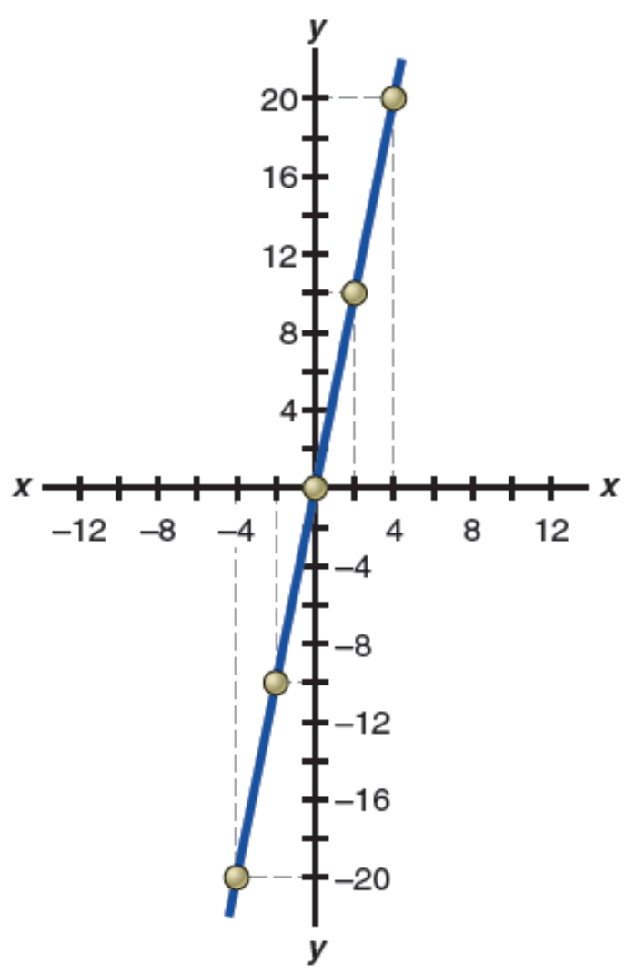  x
 | −4
 | −2
 | 0
 | 2
 | 4

y | x
−20 | −4
−10 | −2
0 | 0
10 | 2
20 | 4

A-6. Given the function y = 8 – 2x, complete the following schedule and plot the curve. (See page 23.)
y | x
 | −4
 | −2
 | 0
 | 2

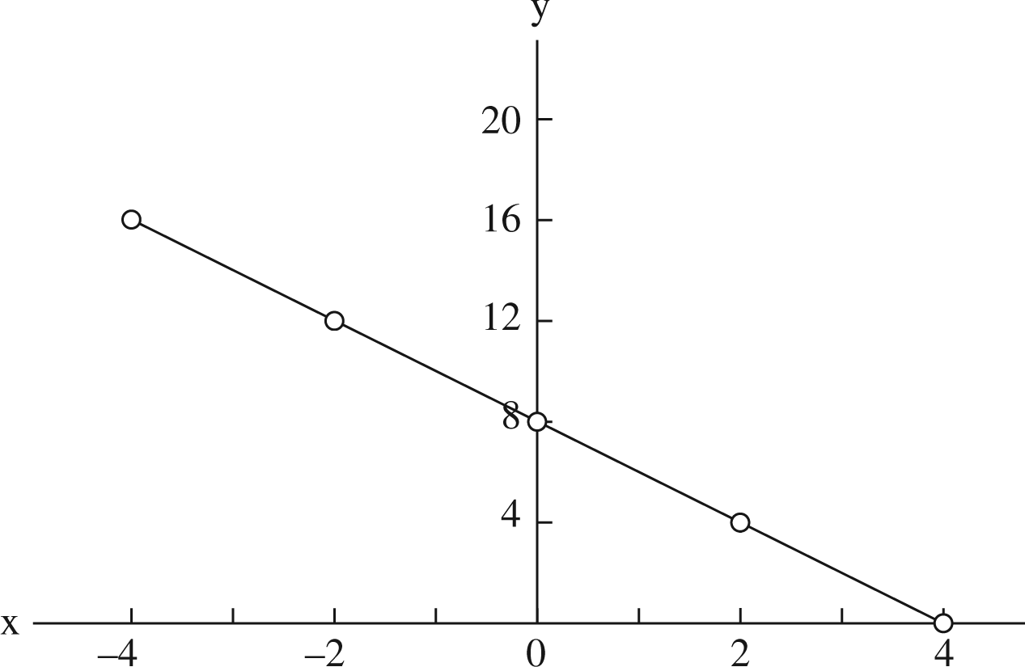
4

y | x
16 | −4
12 | −2
8 | 0
4 | 2
0 | 4

A-7. Given the function y = 8 – 2x, complete the following schedule and plot the curve. (See page 23.)

Each one-unit increase in x yields a 5-unit increase in y, so the slope given by the change in y corresponding to the change in x is equal to 5.

A-8. Given the function y = 8 – 2x, complete the following schedule and plot the curve. (See page 23.)

Each 1-unit increase in x yields a 2-unit decrease in y, so the slope given by the change in y corresponding to the change in x is equal to −2.

Selected References
Fellner, William, The Emergence and Content of Modern Economic Analysis, New York:
McGraw-Hill, 1970.
Friedman, Milton, “The Methodology of Positive Economics,” in Essays in Positive Economics,
Chicago: The University of Chicago Press, 1953.
Hirshleifer, Jack, “The Expanding Domain of Economics,” The American Economic Review,
December 1985, pp. 53–68.
Keynes, John N., Scope and Method of Political Economy, 4th ed., New York: Macmillan, 1955.
Robbins, Lionel, Essay on the Nature and Significance of Economic Science, 2nd ed., London:
Macmillan, 1935.

